SUPPLEMENTARY MATERIAL

Skeletal muscle involvement in patients with truncations of titin and familial dilated cardiomyopathy

**Table of contents**

**Supplementary methods S1** 3

*Magnetic Resonance Imaging Protocol* 3

*Muscles investigated* 3

*Skeletal muscle biopsy handling, staining and analyses* 4

**Sup Figure 1 –** Cardiac phenotypes and systolic function and change in systolic function of included subjects with TTNtv 5

**Sup Figure 2 –** Overall effect of carrying a TTNtv on muscle fat replacement 6

**Sup Figure 3-** Ridge plot comparing fat fractions in individual leg-muscles 7

**Sup Figure 4 –** Ridge plot comparing fat fractions in individual back-muscles 8

**Sup Figure 5 –** Linear correlations of muscle fat fractions and age 9

## **Supplementary methods S1**

### *Magnetic Resonance Imaging Protocol*

Subjects were scanned with a head, neck and spine coil, two body matrixes and a peripheral angio coil in a head first, supine position in a 3.0 T Siemens scanner (Magnetom Verio Tim System; Siemens AG, Erlangen, Germany). The MRI protocol included whole body three-planned localizers (echo time [TE] = 85 msec, repetition time = 1500 msec, slice thickness = 6.0 mm, distance factor = 100% between slices, and field of view was 480 mm. ), axial T1-weigthed imaging at C6, Th12, L4, S2 mid thigh and mid calf (TE = 25 msec, repetition time = 550 msec, slice thickness = 6.0 mm, distance factor = 20% between slices, and field of view was 400 to 500 mm. ) and axial Dixon imaging at C6, TH12, L4, S2 mid thigh and mid calf ((TE = 2.45, repetition time = 5.59, slice thickness = 3.5 mm, distance factor = 20 %, field of view = 400 to 500 mm.).

### *Muscles investigated*

In total, we investigated 9 individual muscles of the back and 20 individual muscles of the legs. Fat fractions in muscles of the back were evaluated individually and included the deep back muscles at C6, erector spinae at Th12 and L4, multifidus at Th12 and L4, psoas major, and gluteus maximus, medius, and minimus. We evaluated 10 muscles at the midpoint of the thigh, grouped into three compartments: the anterior, medial, and posterior thigh compartments. Muscles of the anterior thigh included rectus femoris, sartorius and vastus lateralis, medialis, and intermedius muscles. Muscles of the medial thigh included the adductor and gracilis muscles. Muscles of the posterior thigh included biceps femoris, semitendinosus, and semimembranosus muscles. At the thickest point of the calf, a third of the distance from the knee to the ankle, we evaluated a total of 10 muscles, grouped into five compartments: the anterior, lateral, medial superficial posterior, lateral superficial posterior and posterior compartments. Muscles in the anterior calf compartment included tibialis anterior and extensor digitorum longus muscles. Muscles of the lateral calf compartment included the peroneus longus and brevis muscles. The medial gastrocnemius muscle made up the medial superficial posterior calf compartment, while the lateral gastrocnemius and soleus muscles made up the lateral superior posterior compartment. Finally, the posterior calf compartment included the tibialis posterior, flexor digitorum longus and flexor hallucis longus muscles.

### *Skeletal muscle biopsy handling, staining and analyses*

Muscle biopsies were taken from Vastus Lateralis using a Bergstrøm needle. A piece was flash frozen in isopentane cooled in liquid nitrogen and stored at -80C and a piece was fixed in glutaraldehyde for a minimum of 48h in phosphatebuffer at 4C.

## **Sup Figure 1 –** Cardiac phenotypes and systolic function and change in systolic function of included subjects with TTNtv

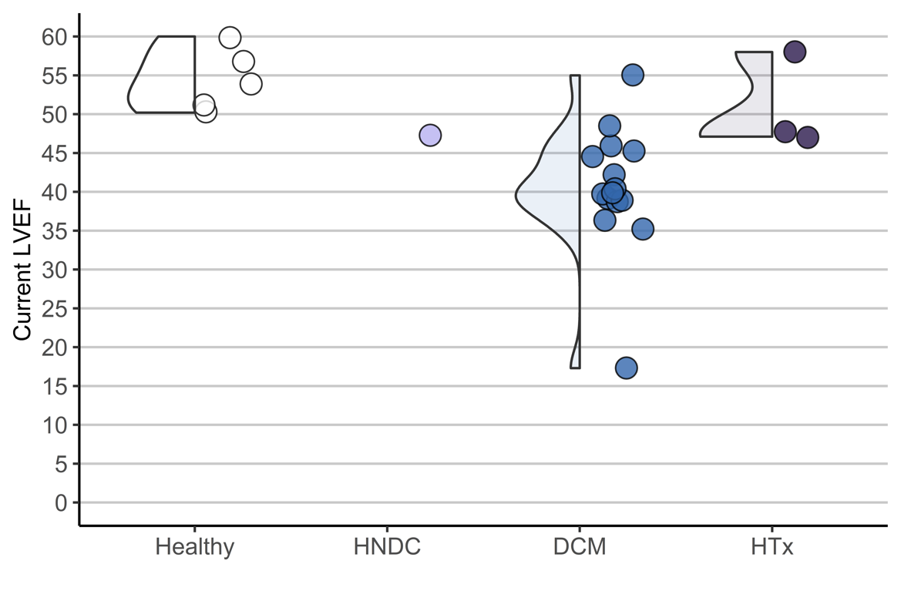

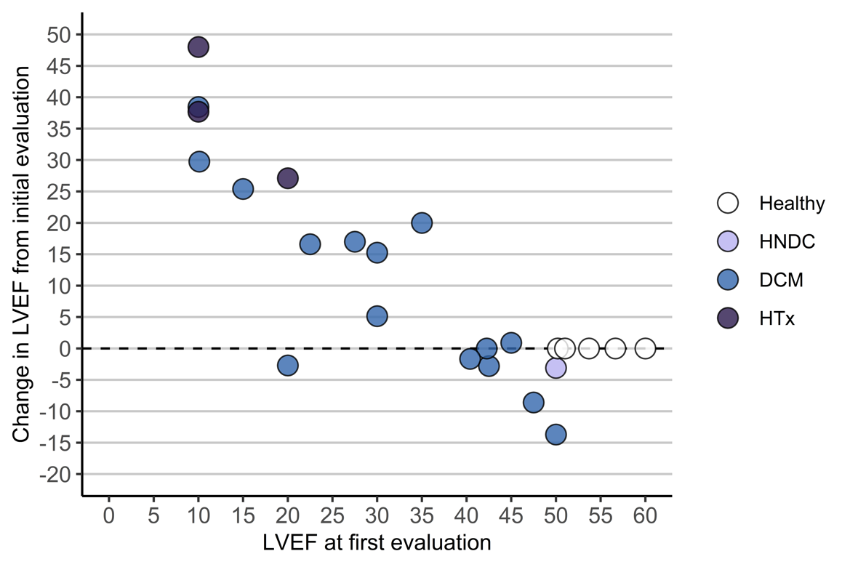

**Legend:** Systolic function in included subjects with TTNtv. The top graph shows the left ventricular ejection fraction (LVEF) at the time of the study, in subjects according to (worst diagnosed) cardiac phenotype. In the bottom graph, the change in LVEF from time of cardiomyopathy diagnosis (if relevant) is visualized according to LVEF at initial evaluation.

## **Sup Figure 2 –** Overall effect of carrying a TTNtv on muscle fat replacement

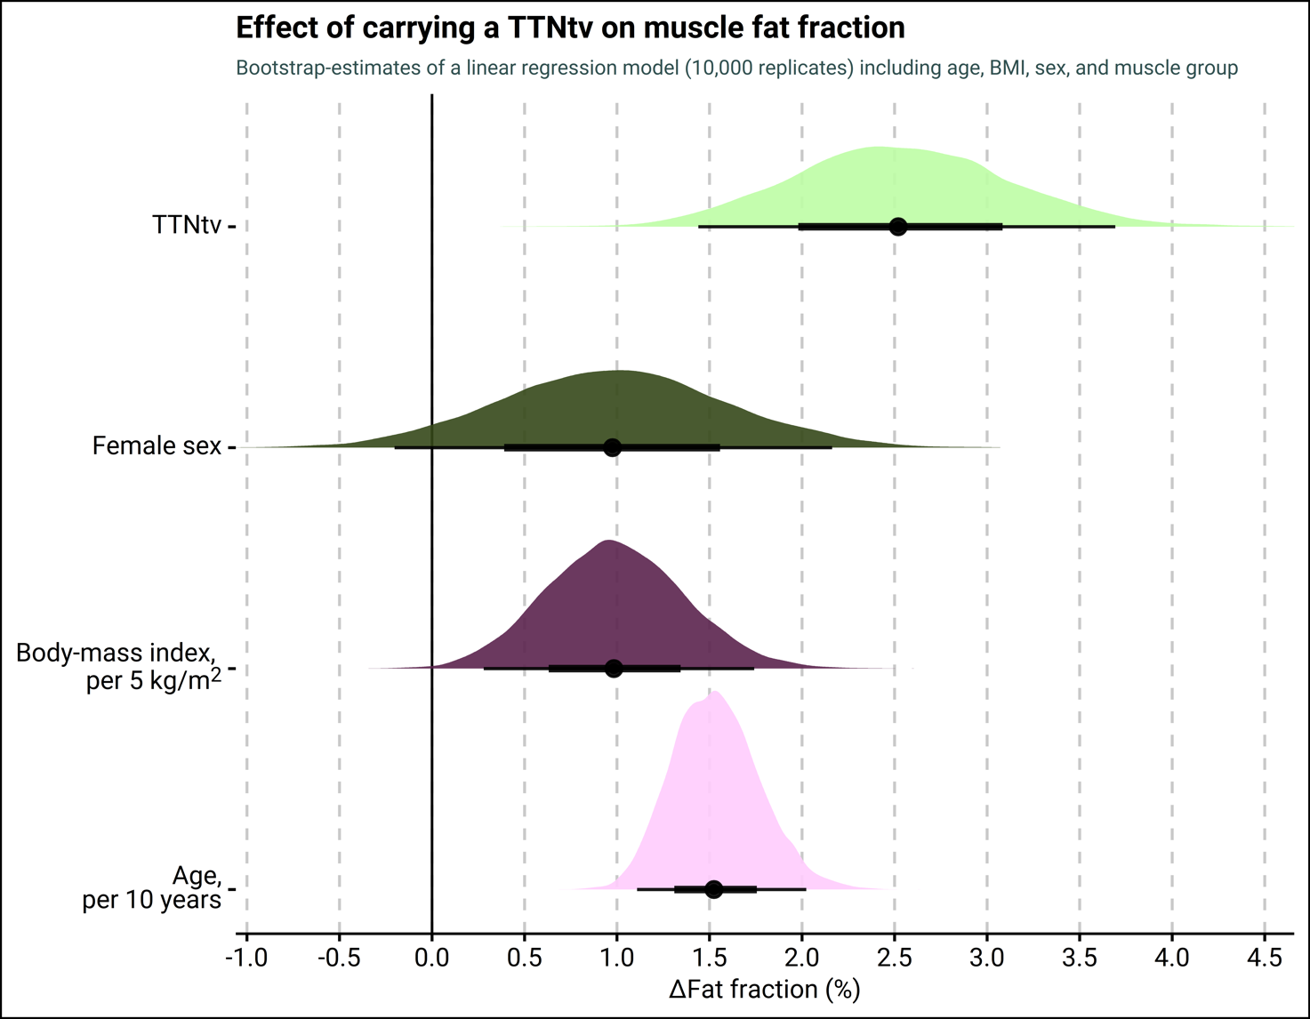

**Legend:** Results from ordinary least square regression of the fat fraction in skeletal muscle across all muscle groups. The effect estimates and confidence intervals are calculated from 10,000 multiple linear regression models performed on datasets created by bootstrap resampling with replacement of our study cohort (stratified by group). The colors denote the density function of point-estimates from the model, while the slab provides the point estimate (point) and the 66% (thick part) and 95% (thin part) uncertainty intervals from the probability density function.

## **Sup Figure 3-** Ridge plot comparing fat fractions in individual leg-muscles

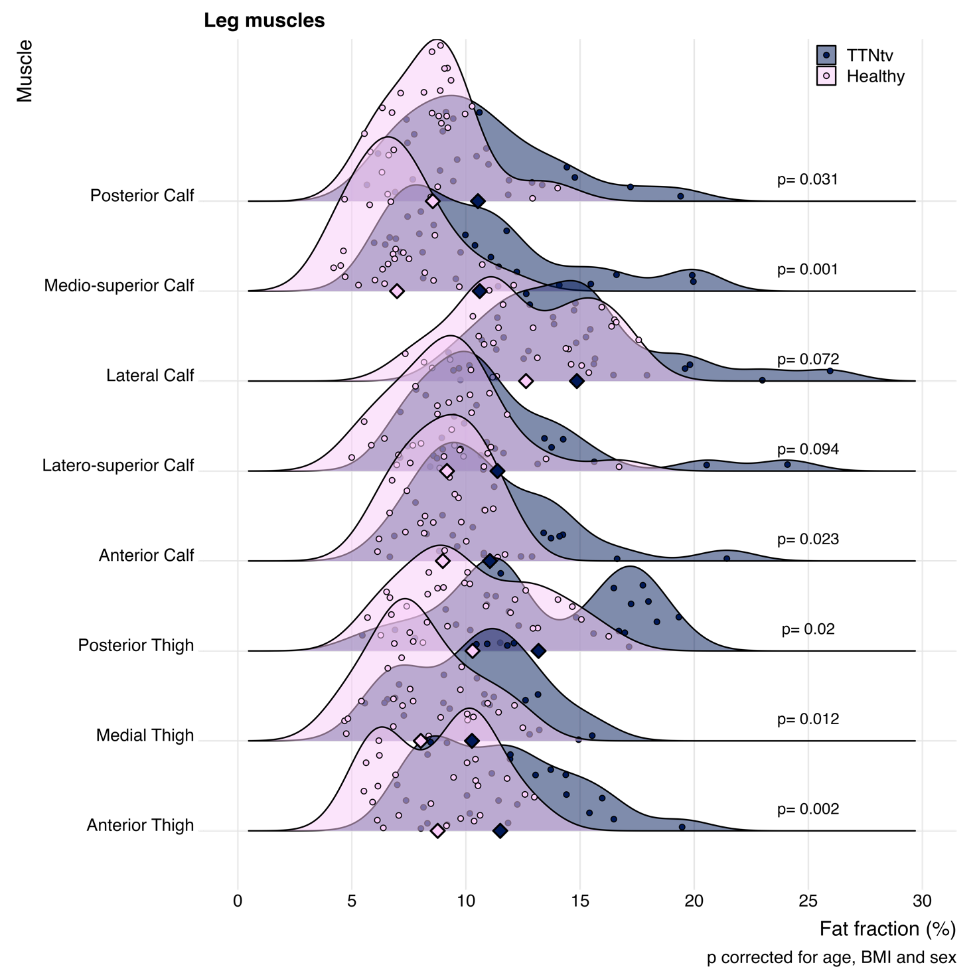 **Legend:** Ridgeline plot, showing the overall distribution and individually measured fat fractions of muscle-groups in the legs of participants with TTNtv (pink) and healthy controls (dark blue). The observed fat fraction was nominally higher in the TTNtv group in all muscles, of which the between group difference was statistically significant in 6 of 8 muscles.

## **Sup Figure 4 –** Ridge plot comparing fat fractions in individual back-muscles

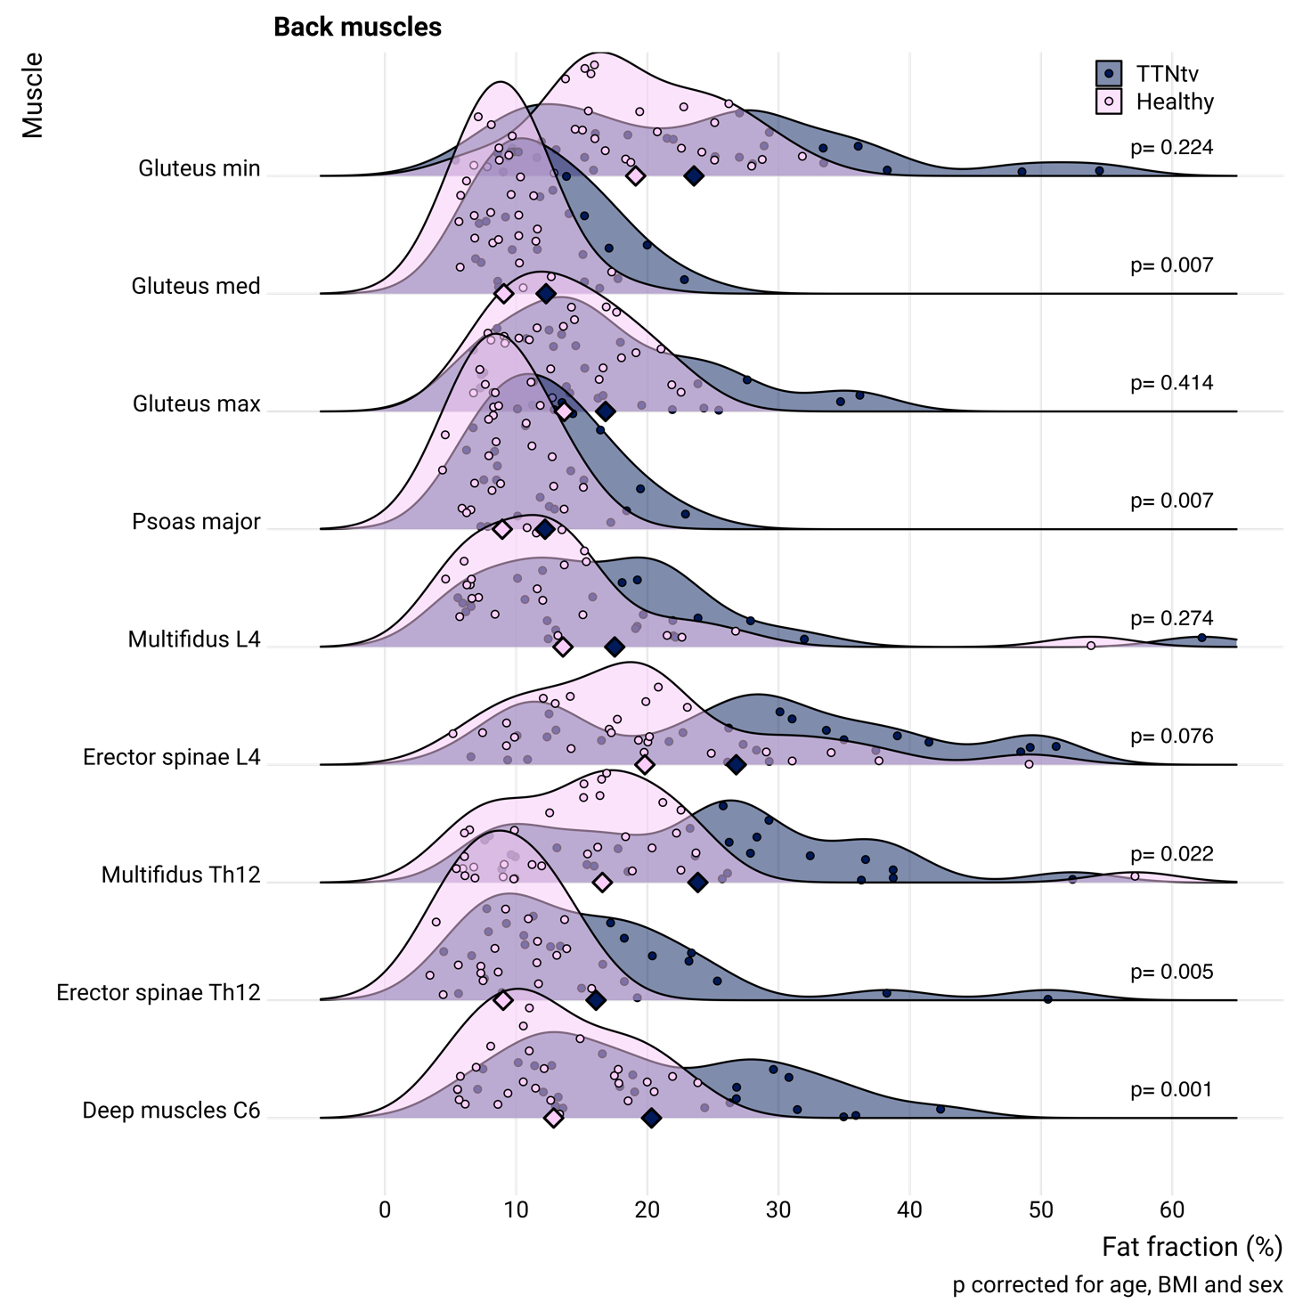**Legend:** Ridgeline plot, showing the overall distribution and individually measured fat fractions of paraspinal and lower back muscles in participants with TTNtv (pink) and healthy controls (dark blue). The observed fat fraction was nominally higher in the TTNtv group in all muscles of which the between group difference was statistically significant in 5 of 9 muscles.

## **Sup Figure 5 –** Linear correlations of muscle fat fractions and age

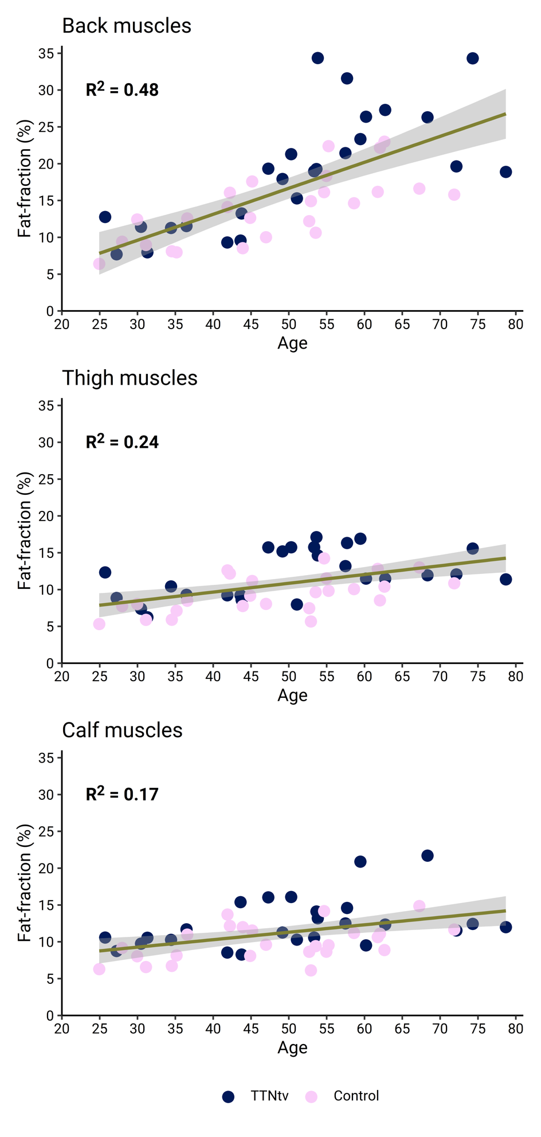

**Legend:** Relationship between fat fraction of muscles and age in subjects carrying TTNtv and healthy controls grouped together. Values from individual patients are represented by points and are colored according to group. The correlation between age and fat fraction was significant in all muscle groups although the correlations was markedly stronger for back- compared to thigh- or calf muscles.

## **Sup Table 1 –** Clinical characteristics

| **Characteristic** | **TTNtv**, N = 25 | **Controls**, N = 25 | **p-value***2* |
| --- | --- | --- | --- |
| Females | 11 (44%) | 12 (48%) | 0.8 |
| Body-mass index | 26.6 (IQR: 24.8 to 34.0) | 25.4 (IQR: 24.0 to 28.2) | 0.2 |
| Age, years | 51 (15) | 48 (13) | 0.6 |
| Cardiac medications | | | |
| RAAS | 15 (60%) | NA | - |
| Betablockers | 11 (44%) | NA | - |
| MRA | 4 (16%) | NA | - |
| Diuretics | 9 (36%) | NA | - |
| Amiodarone | 2 (8%) | NA | - |
| DOAC | 3 (12%) | NA | - |
| Prednisolone | 3 (12%) | NA | - |
| Everolimus | 2 (8%) | NA | - |
| Ciclosporin | 2 (8%) | NA | - |
| Co-morbidities |  |  |  |
| Diabetes | 3 (12%) | NA | - |
| Hypertension | 4 (16 %) | NA | - |
| Atrial fibrillation | 4 (16%) | NA |  |
| Reported symptoms | | | |
| Muscle soreness | 6 (24%) | NA | - |
| Muscle weakness | 5 (20%) | NA | - |
| Muscle wasting | 2 (8%) | NA | - |
| Fatigue | 6 (24%) | NA | - |
| Syncope (any cause) | 5 (20%) | NA | - |
| Palpitations | 9 (36%) | NA | - |
| Imaging and plasma biomarkers of cardiac and muscle function | | | |
| Thigh muscles CSA, cm2 | 109 (20) | 129 (34) | 0.039 |
| Calf muscles CSA, cm2 | 52 (13) | 58 (12) | 0.11 |
| Plasma creatine kinase, U/I | 109 (IQR: 85 to 195) | NA | - |
| Plasma myoglobin, µg/L | 51 (IQR: 39 to 68) | NA | - |
| Plasma NT-proBNP, pmol/L | 11 (IQR: 6 to 40) | NA | - |
| Plasma creatinine, μmol/L | 82 (IQR: 71 to 104) | NA | - |
| **Abbreviations**: CSA = cross-sectional area, DOAC = direct-acting oral anticoagulants, NT-proBNP = N-terminal prohormone of brain natriuretic peptide, MRA = mineralo-receptor antagonist, RAAS = renin-angiotensin-aldosterone system inhibitors. | | | |